**Дата**: 12.12.2024

**Клас**: 9-А

**Предмет**: англійська мова

**Тема:** Діагностична робота з теми «Робота та професії».

**Мета:** : формувати навички вживання лексичних одиниць по темі; удосконалювати навички читання, аудіювання й усного монологічного мовлення; розвивати пізнавальні інтереси учнів; виховувати інтерес до самостійного пошуку потрібної інформації, а також загальну культуру учнів.

**Вчитель**: Руда Д.В.

Хід уроку

1.Greeting

Good afternoon, guys! I’m glad to see you. Are you ready to start our lesson? All set?

2. Wаrm up / Listening

Уважно слухати аудіо трек і дати відповідь на питання <https://www.youtube.com/watch?v=EYeWA8_TlTY> .

3. Speaking

Дати усно відповіді на питання :

Are you a hard worker? What motivates you to work?

When you were a child, what did you want to be when you grew up?

If you could do a job for one day to learn what it is like, what would you do?

Where is the best place to look for work these days?

What qualities should a good boss have?

How many vacation days do workers in your country usually get per year? Is it enough?

How important is it to get along with co-workers? Is it a good idea to socialize with them outside work?

What do you think about office romances? Is it unwise to get romantically involved with a coworker? Why?

Are you an ambitious person? What career goals do you have?

What is the usual retirement age in your country? Should it be changed?

Which professions are very well-paid these days? Why are those workers highly valued?

Are there any jobs you think are not paid enough? Why are those workers undervalued?

4. Повторення

Повторити фразу to be into something/to be good at smth/to be interested in smth.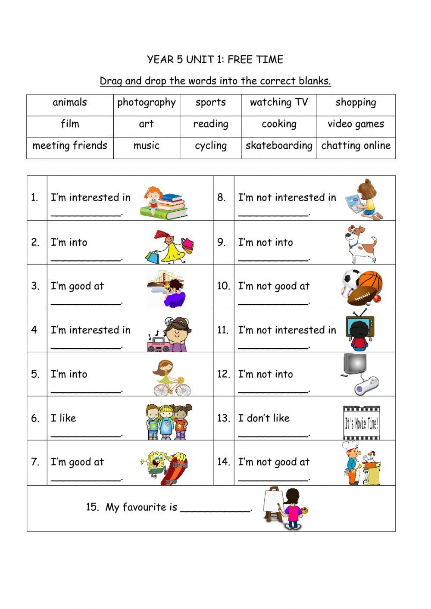

Повторити Conditional sentences.

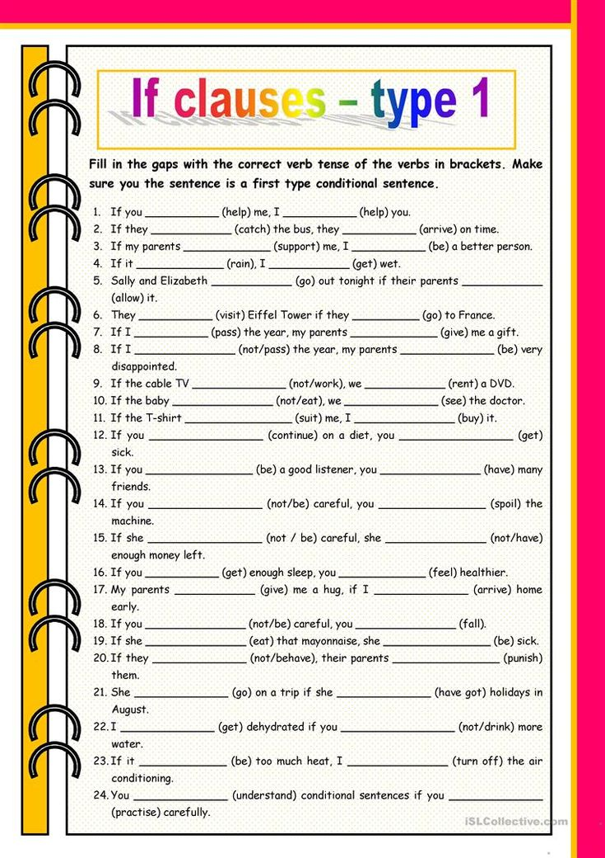

5. Writing

Написати міні-есе на одну з поданих тем :

1.Some jobs, like president of a country, are powerful, but come with a lot of responsibility. How do you handle responsibility? Do you want more?

2.If every job paid the same amount of money, which job would you prefer to do?

6. Homework

1. Виконати вправу 5 стр 113.

2. Виконати контрольний тест на платформі «На урок» [join.naurok.ua](http://join.naurok.ua/)

Код доступу 4125409 .